**Auditing with Microsoft Assessment and Planning (MAP) Toolkit 5.0 – Part 1**

By [Sadequl Hussain](http://www.sql-server-performance.com/author/sadequlhussain/)

FROM: <http://www.sql-server-performance.com/2015/auditing-map-5-1/>

Auditing and inventorying is not something new in any IT environment. Depending on the purpose, it can take many forms. Sometimes the auditing is about security and data access. Sometimes it is about software usage and licensing. Often it is about consolidation and cost saving. Whatever the reason, the strategic direction typically comes from top management or decision makers. It is then up to the technical personnel or operation managers to come up with some sort of report that shows the figures.

Consider the following scenarios:

* Your company has decided to upgrade its core business application to SQL Server 2008 R2 and you are the DBA. You are to submit a feasibility study about whether the existing server has sufficient computing resources for an in-place upgrade.
* Your manager has just asked you to send a list of SQL Servers running within the organisation. The commercial procurement team needs to have an idea about the number of SQL instances running in the network. They need the version and edition and they also need to know what version of Windows is running in those boxes. The total number will have to be broken down by category.
* As an IT manager, you are considering rolling out Windows 7 and MS Office 2010 on user desktops. You need a starting point, some sort of baseline that will give you an idea if the user workstations are powerful enough for the upgrade. On the server side, you are also considering virtualising some of the physical servers. You want a clear idea about the number of VMWare hosts sitting across the network.
* Experts from a vendor company have recently come and rolled out a system for your organisation. The farm consists of web servers, app servers and database servers. You want to monitor the performance of each of the servers and check whether they conform to what the vendor had promised. You want the performance metrics from all these servers collected automatically and you want them to be consolidated in a single report.

The list can go on. Although there are tools for finding the information for each possible scenario, most of them would either require a licensing fee or they have to be custom developed, meaning there will be a dollar figure attached.

Instead of resorting to either approach, IT specialists can take advantage of some of the free tools available from Microsoft.  **Microsoft Assessment and Planning (MAP) Toolkit** is one such free application that can automate the auditing and inventorying process to a great extent. MAP is part of what Microsoft calls **Solution Accelerators**: software applications that help you take tally of what is running on your network and plan for better consolidation strategy.

Like I said, this type of tool is not something new. However, what sets MAP apart is its low footprint. Typically, the auditing software would be running on a centralised server with “agents” running on each machine. These Agents would have to be installed in each server individually and they will communicate with the central server on a set schedule.

MAP does not need any such agent. In fact it does not have to be installed on a server either and there is certainly no need to use a database back-end for which you have to pay a license fee. You can install it on a workstation running Windows XP, Vista or 7 and it will create a repository database running on SQL Server Express edition – which is free. Once installed, configured and running, MAP can go across the network and query each machine (servers or workstations), find its hardware configuration, see what software is running on it, what role it has in the network and then save that information in the local database. In MAP lingo, this process is called “inventorying”. It can then analyse the data collected and provide you with a detailed report and even generate a proposal document.

Although the tool reflects Microsoft’s approach to encourage customers to upgrade to its newer server and client technologies, it has it uses nevertheless. Even if you are not upgrading your servers overnight based on its recommendations, you still will have some useful information at hand.

**System requirements**

At the time of this writing, MAP is in version 5. It is available for free from the [download page](http://www.microsoft.com/downloads/details.aspx?displaylang=en&FamilyID=67240b76-3148-4e49-943d-4d9ea7f77730).

At a hardware level, the minimum CPU speed of the machine running MAP would have to be 1.6 GHz. Microsoft suggests dual core 1.5 GHz processors or faster. Memory requirement is 1.5 GB while hard drive space requirement is 1 GB.

At an OS level, MAP can run on any of the following client operating systems:

* Windows 7
* Windows XP Professional with SP2 or later

If you want MAP to be installed on a server, the supported OS include:

* Windows Server 2008 and 2008 R2
* Windows Server 2003 R2

The following are also required components:

* .NET framework 3.5 SP 1
* Windows Installer 4.5

Now it may sound logical to install such an auditing tool on a centralised server instead of a client workstation. However, MAP also requires MS Word 2007 (SP2) or MS Word 2010 as well as MS Excel 2007 (SP2) or MS Excel 2010 available in the machine where it is running:

Since MS Office is not typically found in server environments, running MAP installation in such cases will be unsuccessful. The following figure shows the error message I received when trying to install MAP in a server that did not have MS Office installed.

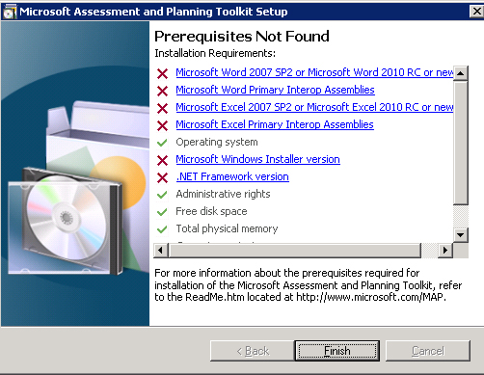

As most client workstations would have MS Office installed, a dedicated workstation can be a viable option. This can be the system administrator’s own workstation. Once the application has gained acceptance from management, a server environment can be allocated and configured.

Last but not the least, MAP requires SQL Server 2008 R2 Express Edition for its data storage. Even if the machine already has an instance of SQL Server 2008 R2 Express already running, the setup program will still create a new instance. The instance name will be **MAPS**. MAP ensures this instance is exclusively configured for its purpose: it does not allow connections from remote computers and local access to the instance is limited to members of the local administrators only.

**Installation**

Installing MAP is a fairly straightforward process. If the prerequisites are met, the wizard takes you through only a few screens. I would suggest turning on the checkbox at the very first screen that says “Automatically download and installed updated device compatibility and reference information, and automatically check for application updates”.

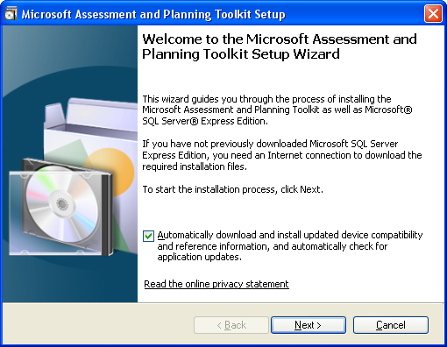

Also, the installer can download and install the SQL Server 2008 R2 Express edition during system setup, but you can direct it to the setup program in the disk.

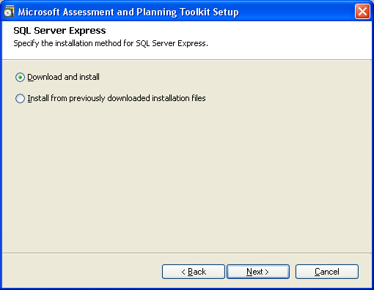

By default, MAP is installed in the Program Files directory. If your Program Files folder is under the C: drive, it will be C:Program FilesMicrosoft Assessment and Planning Toolkit

The following figure shows the various subdirectories created under the main folder:

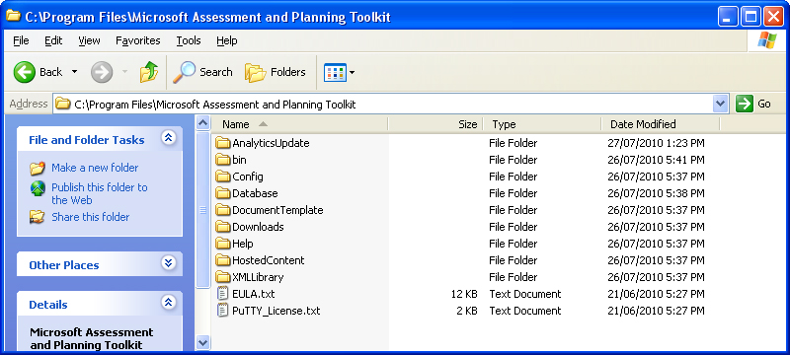

There will also be two databases created in the SQL Server 2008 R2 Express instance: MAP_ConfigInfo and SystemInfo. The third one will need to be created when you use MAP for the first time.

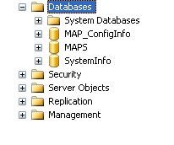

Although it may seem obvious, the database files for MAP toolkit is not created under the Databases folder of the program directory. They will be under C:Program FilesMicrosoft SQL ServerMSSQL10_50.MAPSMSSQLDATA

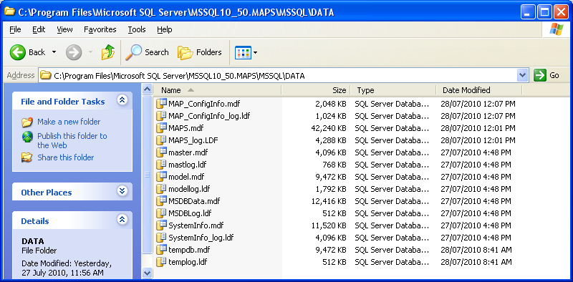

However, I would strongly suggest *not* doing anything manually to the databases outside MAP. It is best you leave it alone the way it is. If you want to backup the database, there are scripts to do that and we will have a look at that later.